Prehistoric Florida

By:

Marcus Elosegui

Frankie Prozor

Jarrod Maloney

**Abstract**

In this essay, our group aims to explain our thought process going through the production of our app: starting from what inspired us to make it, and going all the way to our end result. The first section that will be discussed, as was previously mentioned, is the background: how we got involved with the Museum of Discovery and Science. Following that is our methods: how we laid out our responsibilities and decided on content inclusion. Logically, following the methods is the results section, in which we shall explain our app’s functionality and provide images. Additionally, this essay includes a discussion section, which relies on ways to better fill out our app, a conclusion section to discuss how we feel about what we accomplished, and acknowledgements/credits and resources sections.

**Background**

The inception of our app began with our joining the prestigious Museum of Discovery and Science’s *APPtitude* internship program, in which we would spend approximately two years building upon the museum’s existing exhibits with our newfound knowledge of said exhibits and the help of a coding class at Florida Atlantic University. Our group selected the prehistoric Florida section to build upon based on quite basic logic. Seeing as we were from Florida, we were intrigued at the chance to learn more about our alluring state’s history as well as what changes it might have undergone over time. Realizing this, we jumped on the topic immediately and began our research promptly.

**Methods**

Upon beginning our research, we decided that it would better our exhibit to provide supplementary information in the app, as opposed to procuring exactly what the area already presents to visitors. As such, we found information about the lesser known prehistoric animals, added a trivia game, and enhanced both the sea level changes and dig pit components of said exhibit. Our team was divided into three parts upon our reception of the task above: Frankie was to work in the graphics area, Marcus in the Java area, and Jarrod in the User Interface area (before we would bring all of our work together).

Our biggest challenges were fitting buttons to the device screen, enabling scrolling in *Android Studio*’s default *TextView* text boxes, and properly displaying a GIF image. In solving the first problem, we scaled down the graphics to prevent them from taking up half of the screen, and to allow them to fit into each page’s respective relative, linear, and grid layouts. Next, we fixed the scrolling problem by removing our existing text boxes and positioning new ones in their place, assigning them each the parent of a *scrollview*. Lastly, and most challengingly, the GIF image problem was solved by converting the GIF to an MP4 video, and putting said video in the layout under the *WebView* tool. When coupled with Java, such a move enabled us to display Frankie’s GIF exactly as we wanted it.

The biggest java challenge was modifying the quiz app to work for our purposes. When we went in and changed the questions and the amount of questions in the SQLite database the app would crash when trying to run the trivia game. We tried to use Logcat to narrow down where in the code was it breaking down, but it only led to a false positive we we narrowed it down to the wrong portion of the code. The problem was eventually found to lie in the random number generator which decided which questions would be displayed . It was originally generating from 1 to 30 which would crash the app if it generated a number higher than the amount of questions we had. The problem was simply fixed to generate random numbers between 1 and the amount of questions we had.

**Results**

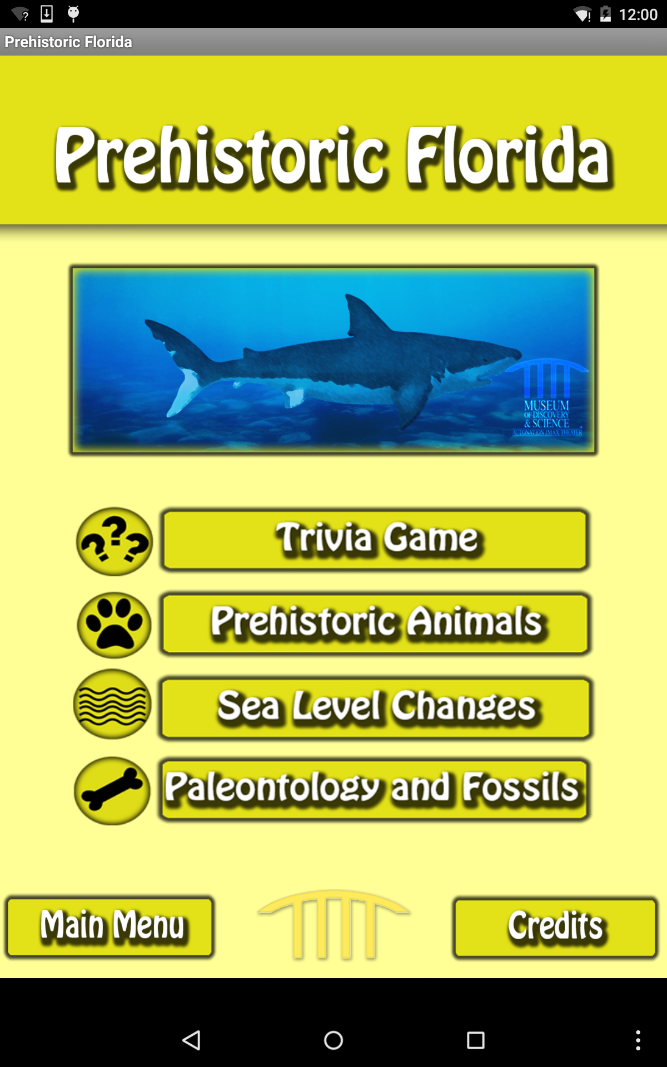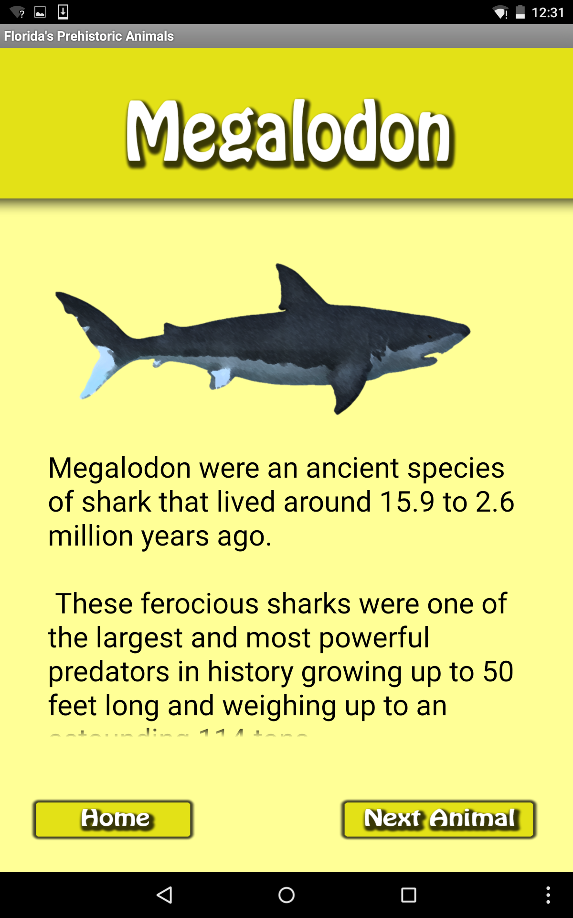

Prehistoric Florida starts off with the main four buttons: Trivia Game, Prehistoric Animals, Sea Level Changes, Paleontology and Fossils. The Trivia Game section is a 10 question quiz about all the sections in our app. The Prehistoric Animals section has pictures and information about different animals that lived in Florida’s prehistory. The Sea Level Changes section includes and animation of ice melting and sea levels rising along with information about that. The Paleontology and Fossils section gives information about the fossils that can be found in the dig pit in the museum. The Credits button leads to our credits and the Main Page button leads to the home page that the *Discovery Center* made in an effort to integrate our apps.

**Discussion**

While we did get a lot of our app done there is still a lot of work to be done to make this a complete app. Music still needs to be better integrated within our app. As for the Paleontology and Fossils section, there still needs to be work done on the popups as well as adding more information to that section. More information could be added to Sea Level changes, as well as new animals to Prehistoric Florida. More questions could be added to the Trivia Game to keep the content fresh and from getting stale too quickly.

**Conclusion**

Overall, our app-making experience was a success. While we initially faced a multitude of problems ranging from graphics, to UI, to Java; most were able to be corrected as we continued to familiarize ourselves with *Android Studio*. The most challenging aspect of said process was likely the initial phase of development, seeing as we had to build our app from the ground up preceding the introduction of reference materials such as the flag quiz and mobile trivia files. Working out the kinks in getting the UI and graphics to sync, as well as getting used to Android Studio’s variations on Java, was quite a course in itself. As such, our work was cut out for us, and we are quite pleased with the result of our overall resolutions. The Project can be found here: <https://github.com/MODSApps/Prehistoric-Florida-App> . More specifically the latest version of our project will be in the Project Assignment 3 folder.

**Acknowledgements/Credits**

We would like to thank West Broward High School, as well as the teachers and teaching assistants from Florida Atlantic University including Ravi Shankar, Francis McAfee, Santiago Aguerreuere, and Demetrius Dukes. Additionally, we credit Summer Scarlatelli and Joe Cytacki for their work in putting this program together, as well as the Museum of Discovery and Science for hosting said program and providing the basis of our apps. Lastly, we would like to thank United Way for sponsoring our efforts and the *Apptitude* program. Our group utilized <http://www.fossil-treasures-of-florida.com/> for research purposes throughout the app.

**References**

Megalodon - By Dinosaur Zoo (Own work) [CC BY-SA 3.0 (http://creativecommons.org/licenses/by-sa/3.0)], via Wikimedia Commons. With modifications.

Terror Bird - Snowmanradio (talk) Paraphysornis_BW.jpg: Nobu Tamura (http://spinops.blogspot.com) - Paraphysornis_BW.jpg. With modifications.

Woolly Mammoth - By Flying Puffin (Mammut Uploaded by FunkMonk) [CC BY-SA 2.0 (http://creativecommons.org/licenses/by-sa/2.0)], via Wikimedia Commons. With modifications.

Cave Bear - Sergiodlarosa [GFDL (http://www.gnu.org/copyleft/fdl.html), CC-BY-SA-3.0 (http://creativecommons.org/licenses/by-sa/3.0/) or FAL], via Wikimedia Commons. With modifications."